Office Network Infrastructure
Deployment and Documentation Report
Cisco Packet Tracer Simulation

Technologies: VLANs | 802.1Q Trunking | Inter-VLAN Routing | Cisco CLI | TCP/IP

Prepared by: Devansh Tadhani

Table of Contents
Table of Contents 2
1. Executive Summary 3
2. Project Overview 3
2.1 Objectives 3
2.2 Network Topology Summary 3
3. VLAN Configuration 5
3.1 VLAN Design 5
3.2 VLAN Table 5
3.3 Switch 1 (Floor 1) - VLAN Creation 5
3.4 Port Assignment to VLANs 5
4. 802.1Q Trunk Configuration 7
4.1 Overview of Trunking 7
4.2 Trunk Link: Switch 1 to Switch 2 7
4.3 Trunk Link: Switch 2 to Main Router 7
5. Port Mapping and Interface Documentation 9
5.1 Switch 1 (Floor 1) - Port Map 9
5.2 Switch 2 (Floor 2) - Port Map 9
6. Inter-VLAN Routing Configuration 10
6.1 Router-on-a-Stick Architecture 10
6.2 Router Sub-Interface Configuration 10
7. Patch Panel and Physical Layer Documentation 11
7.1 Simulated Patch Panel Overview 11
7.2 Floor 1 Patch Panel Table 11
8. Troubleshooting and Issue Resolution 12
8.1 Issue 1 - VLAN Not Propagating Across Trunk 12
8.2 Issue 2 - Router Interface Showing as Down 12
8.3 Issue 3 - IP Connectivity Failure Between VLANs 12
9. Testing and Validation 13
9.1 Same-VLAN Connectivity Test 13
9.2 Inter-VLAN Connectivity Test 13
10. Conclusion 14

1. Executive Summary
This report documents the design, configuration, and deployment of a small office network using Cisco Packet Tracer. The project involved building a segmented two-floor network architecture utilizing VLAN technology, 802.1Q trunking, and inter-VLAN routing through a Router-on-a-Stick configuration.
The network was designed to support multiple departments with logical separation, ensuring secure and scalable communication. Throughout the project, hands-on configuration of Cisco switches and routers was performed using the Cisco CLI, along with structured network documentation including port mapping, switch interface documentation, and simulated patch panel connections.

2. Project Overview

2.1 Objectives
- Design and implement a segmented office network with departmental VLANs
- Configure 802.1Q trunk links between switches and from switch to router
- Enable inter-VLAN routing via a Router-on-a-Stick topology
- Perform port mapping and interface documentation for both floors
- Simulate patch panel connections and validate end-to-end IP connectivity
- Troubleshoot and resolve VLAN, trunking, and routing issues

2.2 Network Topology Summary
Component | Details
Simulation Tool | Cisco Packet Tracer
Number of Floors | 2 (Floor 1 and Floor 2)
Switches | 2 x Cisco Catalyst Layer 2 Switches
Router | 1 x Cisco Router (Router-on-a-Stick)
VLANs Configured | VLAN 10 (HR), VLAN 20 (IT), VLAN 30 (Finance) & VLAN 30 (Guest)
Trunk Protocol | IEEE 802.1Q
Routing Method | Inter-VLAN Routing (Router-on-a-Stick)
IP Addressing | Separate subnets per VLAN

2.3 Logical Topology
Traffic flows from end devices through access ports to their respective switch, then across an 802.1Q trunk link to the router's subinterfaces where inter-VLAN routing decisions are made.

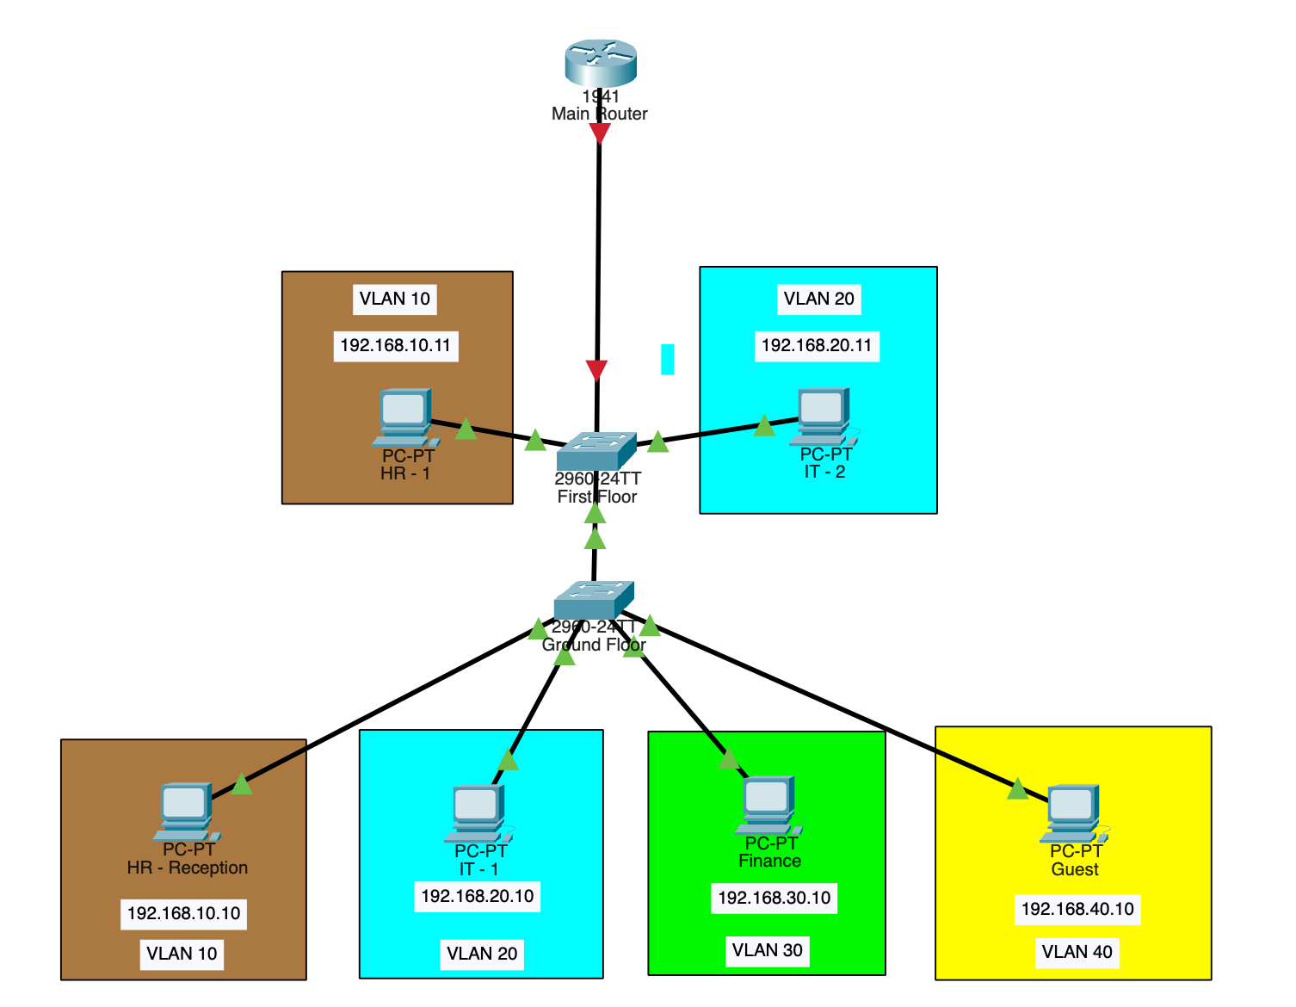
Figure 1 — Full Network Topology in Cisco Packet Tracer

3. VLAN Configuration

3.1 VLAN Design
Virtual Local Area Networks (VLANs) were used to logically segment the office network into isolated broadcast domains per department. This approach enhances security by preventing unauthorized cross-department access at Layer 2, reduces unnecessary broadcast traffic, and simplifies network management.

3.2 VLAN Table
VLAN ID | VLAN Name | Department | Subnet
VLAN 10 | HR | Human Resources | 192.168.10.0/24
VLAN 20 | IT | Information Technology | 192.168.20.0/24
VLAN 30 | Finance | Management | 192.168.30.0/24
VLAN 40 | Guest | Guest | 192.168.40.0/24

3.3 Switch 1 (Floor 1) - VLAN Creation
VLANs were created on Switch 1 using the Cisco CLI. Each VLAN was assigned a descriptive name and associated with the appropriate access ports connected to end devices on Floor 1.

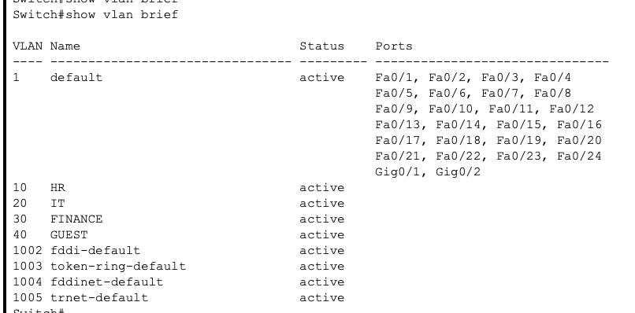
Figure 2: VLAN Creation on Switch 1 (Floor 1)

3.4 Port Assignment to VLANs
Switch ports were configured as access ports and assigned to their respective VLANs. Access ports carry traffic for a single VLAN and are connected to end-user devices such as workstations and printers.

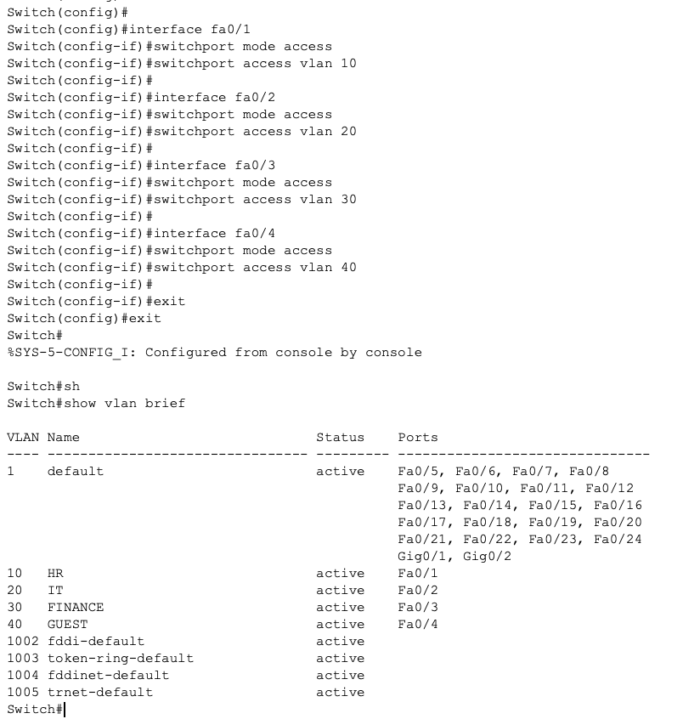
Figure 3: Assigning Ports to VLANs on Switch 1

4. 802.1Q Trunk Configuration

4.1 Overview of Trunking
Trunk links are configured between network devices to carry traffic for multiple VLANs over a single physical connection. The IEEE 802.1Q standard was used, which inserts a 4-byte tag into Ethernet frames to identify the VLAN to which each frame belongs.

4.2 Trunk Link: Switch 1 to Switch 2
A trunk link was established between Switch 1 on Floor 1 and Switch 2 on Floor 2. This allows VLAN traffic to traverse floors without requiring separate physical links per VLAN.

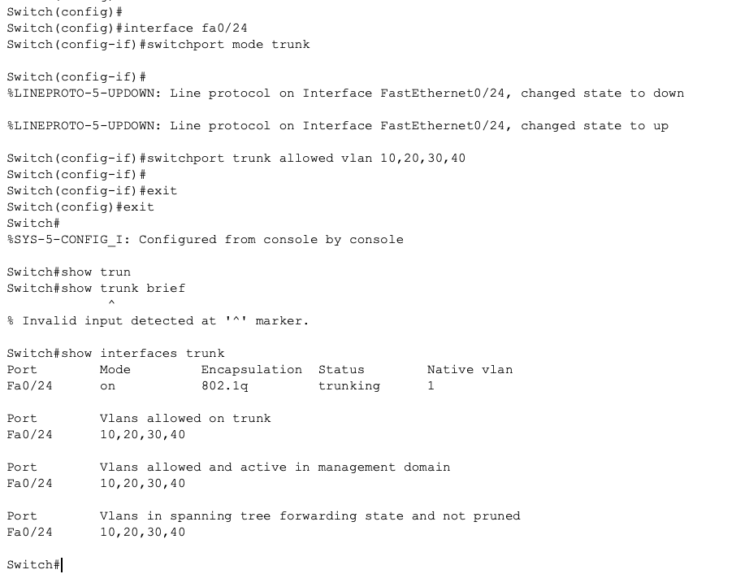
Figure 4: Trunk Link Configuration from Switch 1 to Floor 2

4.3 Trunk Link: Switch 2 to Main Router
Switch 2 on Floor 2 was also configured with a trunk link to the main router. This trunk carries all VLAN traffic to the router, where inter-VLAN routing is performed. The router interface was configured with sub-interfaces corresponding to each VLAN.

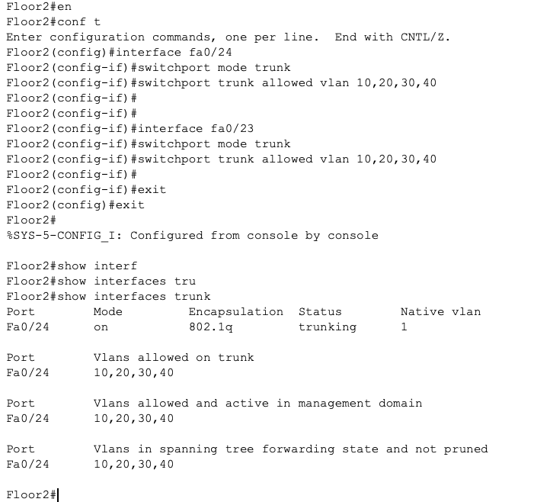
Figure 5: Switch 2 Trunk Configuration Toward Router

5. Port Mapping and Interface Documentation

5.1 Switch 1 (Floor 1) - Port Map
The following table documents all active switch interfaces on Switch 1, including their assigned VLANs, interface modes, and connected devices. This documentation serves as a reference for network audits and future configuration changes.

Port | Mode | VLAN | Connected Device | Notes
Fa0/1 | Access | VLAN 10 (HR) | HR-PC1 | End device
Fa0/2 | Access | VLAN 20 (IT) | IT-PC1 | End device
Fa0/3 | Access | VLAN 30 (Finance) | FIN-PC1 | End device
Fa0/4 | Access | VLAN 40 (Guest) | GUEST-PC1 | End device
Fa0/24 | Trunk | VLANs 10,20,30,40 | SW2 Fa0/24 | 802.1Q uplink

5.2 Switch 2 (Floor 2) - Port Map
Port | Mode | VLAN | Connected Device | Notes
Fa0/1 | Access | VLAN 10 (HR) | HR-PC2 | End device
Fa0/2 | Access | VLAN 20 (IT) | ENG-PC2 | End device
Fa0/23 | Trunk | VLANs 10,20,30,40 | Router G0/0 | Uplink to R1
Fa0/24 | Trunk | VLANs 10,20,30,40 | SW1 Fa0/24 | Inter-switch

6. Inter-VLAN Routing Configuration

6.1 Router-on-a-Stick Architecture
Inter-VLAN routing was implemented using a Router-on-a-Stick topology. A single physical interface on the main router was divided into logical sub-interfaces, each associated with a specific VLAN. The 802.1Q encapsulation on each sub-interface allows the router to identify and route traffic between VLANs.

This method is efficient for small office deployments as it requires only one physical link between the switch and the router, while still supporting full inter-VLAN communication.

6.2 Router Sub-Interface Configuration
Subinterface | VLAN | IP Address | Subnet Mask | Gateway For
G0/0.10 | VLAN 10 (HR) | 192.168.10.1 | 255.255.255.0 | HR PCs
G0/0.20 | VLAN 20 (IT) | 192.168.20.1 | 255.255.255.0 | Eng PCs
G0/0.30 | VLAN 30 (Finance) | 192.168.30.1 | 255.255.255.0 | Finance PCs
G0/0.40 | VLAN 40 (Guest) | 192.168.40.1 | 255.255.255.0 | Guest PCs

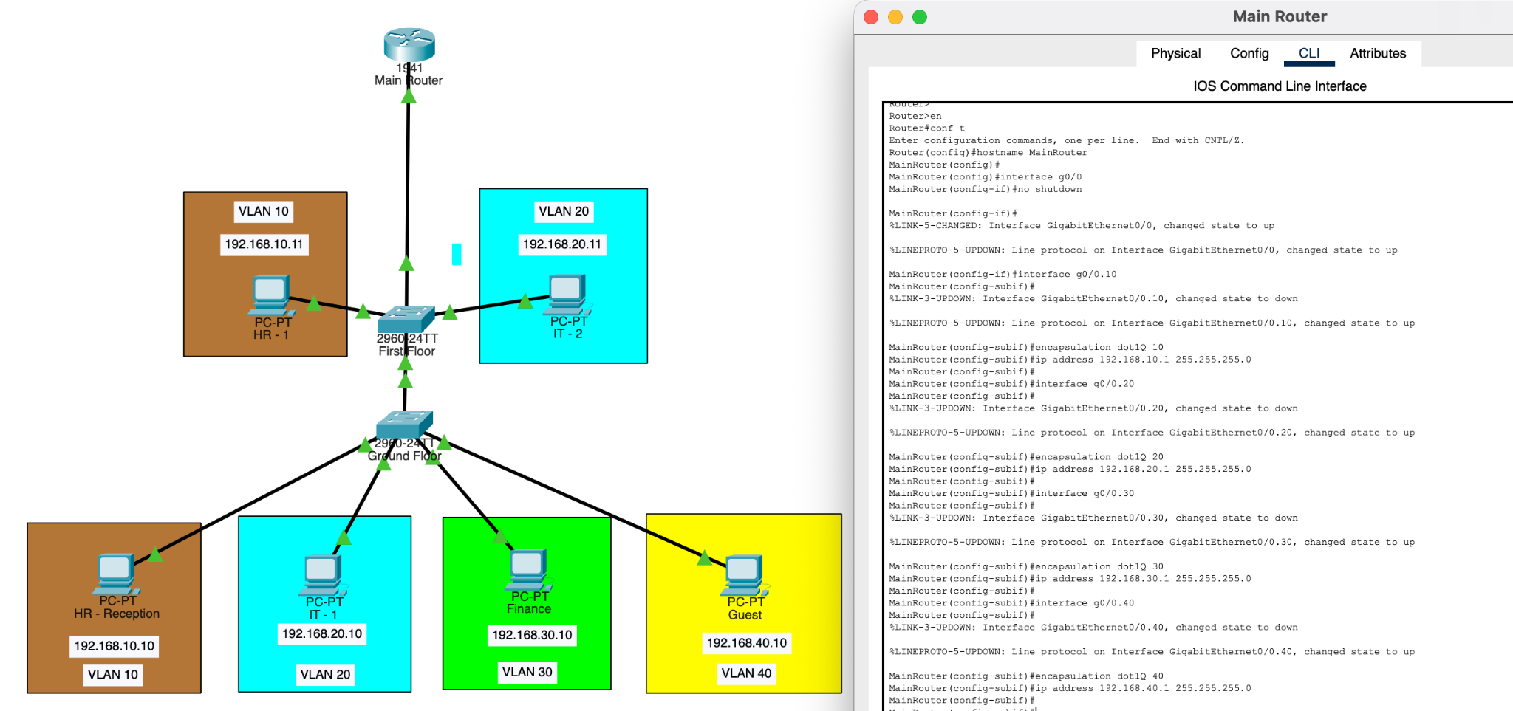
Figure 6: Router Subinterface Configuration (dot1Q Encapsulation)

7. Patch Panel and Physical Layer Documentation

7.1 Simulated Patch Panel Overview
Patch panel connections were simulated to represent the physical cabling infrastructure of the office. Patch panels serve as the central termination point for horizontal cabling runs from workstations to the network closet, where they are then patched to switch ports using short patch cables.

7.2 Floor 1 Patch Panel Table
Device | VLAN | IP Address | Subnet Mask | Default Gateway
HR-PC1 | VLAN 10 | 192.168.10.10 | 255.255.255.0 | 192.168.10.1
HR-PC2 | VLAN 10 | 192.168.10.11 | 255.255.255.0 | 192.168.10.1
IT-PC1 | VLAN 20 | 192.168.20.10 | 255.255.255.0 | 192.168.20.1
IT-PC2 | VLAN 20 | 192.168.20.11 | 255.255.255.0 | 192.168.20.1
FIN-PC1 | VLAN 30 | 192.168.30.10 | 255.255.255.0 | 192.168.30.1
GUEST-PC1 | VLAN 40 | 192.168.40.10 | 255.255.255.0 | 192.168.40.1

8. Troubleshooting and Issue Resolution

8.1 Issue 1 - VLAN Not Propagating Across Trunk
Symptom
Devices on VLAN 20 (IT) on Floor 2 could not communicate with devices on VLAN 20 on Floor 1 after the trunk was established.
Root Cause
The trunk link on Switch 1 was configured with a restricted allowed VLAN list that did not include VLAN 20.
Resolution
The allowed VLAN list on the trunk interface was updated using the command: switchport trunk allowed vlan add 20. This restored cross-floor VLAN connectivity.

8.2 Issue 2 - Router Interface Showing as Down
Symptom
After trunking traffic from Switch 2 on Floor 2 to the main router, the router interface link remained red (down) in Packet Tracer.
Root Cause
The physical router interface had not been brought up using the no shutdown command. By default, Cisco router interfaces are administratively down.
Resolution
The no shutdown command was applied to the physical interface, and subsequently to each sub-interface. The interface came up and inter-VLAN routing became functional.

8.3 Issue 3 - IP Connectivity Failure Between VLANs
Symptom
Pings between devices on VLAN 10 and VLAN 20 failed even after the router sub-interfaces were configured.
Root Cause
The default gateway on end devices was not configured. Without a default gateway pointing to the router sub-interface IP, hosts could not send traffic destined for other VLANs.
Resolution
Default gateways were assigned to each host in their respective VLAN (e.g., 192.168.10.1 for VLAN 10 hosts). Subsequent ping tests confirmed successful inter-VLAN connectivity.

9. Testing and Validation

9.1 Same-VLAN Connectivity Test
Connectivity within the same VLAN was verified first. Devices on the same VLAN successfully pinged each other, confirming that access port assignments and VLAN creation were correct.


Figure 7: Same-VLAN Ping Test (Successful)

9.2 Inter-VLAN Connectivity Test
After the Router-on-a-Stick configuration was completed and default gateways were applied to all endpoints, inter-VLAN ping tests were executed. Devices in VLAN 10 successfully communicated with devices in VLAN 20 and VLAN 30, confirming that routing was functioning correctly.

10. Conclusion
This project successfully demonstrated the design, configuration, and validation of a segmented two-floor office network using Cisco Packet Tracer. The deployment covered the full lifecycle of a small enterprise network, from initial VLAN design and switch configuration to inter-switch trunking, inter-VLAN routing, and systematic troubleshooting.

Key outcomes achieved throughout the project include:
- Successful VLAN segmentation across two floors using IEEE 802.1Q trunking
- Functional inter-VLAN routing implemented via a Router-on-a-Stick topology
- Comprehensive port mapping and interface documentation for both switches
- Simulated patch panel cabling documentation aligned with physical cabling best practices
- Identification and resolution of three distinct network issues related to VLAN propagation, interface state, and IP gateway configuration
- Validated end-to-end connectivity for both same-VLAN and cross-VLAN traffic

The skills applied in this project reflect core competencies expected of a network technician or junior network engineer, including Switch Configuration, VLANs, Port Mapping, Network Documentation, Patching, Troubleshooting, Cisco CLI, and TCP/IP.

